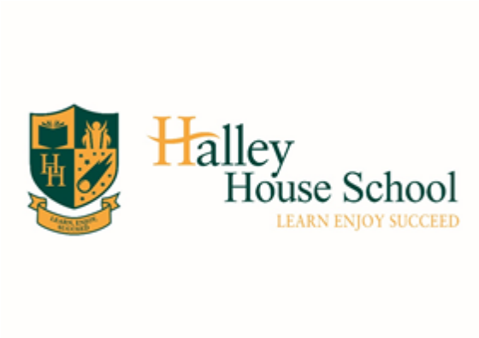

Halley House Charging and Remissions Policy

Signed: | 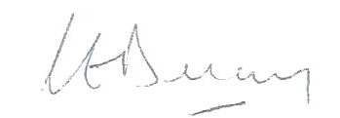
Chair of Trust Board: | Claire Delaney
Approved: | 1 September 2018
Renewal: | 3 Years
Review Date: | September 2021

Contents
1. Bellevue Place Education Trust – Our commitment 2
2. Rationale 2
3. Aim 2
4. Scope 2
5. Charges 3
6. Remissions 3
7. Voluntary Contributions 4
8. Review 4
9. Approval by the Bellevue Place Education Trust Board 4

Bellevue Place Education Trust – Our commitment

Learn. Enjoy. Succeed.

Three words that mean the world to us.
Three words that have been with us from the day we started Bellevue Place Education Trust.
Three words that govern all that we do.

As a parent you can expect excellence, both in how we teach and nurture your child. We foster a positive attitude to life, encouraging a ‘be interested and be interesting’ attitude by providing a rich learning environment full of arts, drama, sport, music and academic rigour.

Bellevue Place children are happy, confident, successful 'all rounders' who expect to win and achieve in an inclusive setting where children, parents and school staff work together to provide the best. Our commitment to you and your child is that we will teach them to learn, enjoy and succeed both in their school career and beyond.

Rationale

The Trust is required to formulate a charging policy for our schools which enshrines fairness and equity and which upholds the principles of inclusion and curriculum access.

Aim

The aim of this policy is to set out what charges will be levied for various activities, what remissions will be implemented by the BPET Board and the circumstances under which voluntary contributions will be requested from parents and carers.

Scope

The Trust recognises that legislation prohibits charges for the following:
- education provided during school hours (including the supply of any materials, books, instruments or other equipment)
- education provided outside school hours if it is part of a syllabus for a prescribed public examination or national test that the pupil is being prepared for at the school, or part of religious education
- tuition for pupils learning to play musical instruments if the tuition is part of a syllabus for a prescribed public examination that the pupil is being prepared for at the school
- education provided on any trip that takes place during school hours
- education provided on any trip that takes place outside school hours if it is or part of a syllabus or scheme of work for a prescribed public examination or national test that the pupil is being prepared for at the school
- supply teachers to cover for those teachers who are absent from school accompanying pupils on a residential trip
- transporting registered pupils to or from the school premises where the local education authority has a statutory obligation to provide transport
- transporting registered pupils to other premises where the school has arranged for pupils to be educated
- transport that enables a pupil to meet an examination or national test requirement
- transport provided in connection with an educational trip organised by the schools

Charges
Charges can be levied as follows:
- board and lodging on residential visits (not to exceed the costs)
- the proportionate costs for an individual child of activities wholly or mainly outside school hours (‘optional extras’) to meet the costs for:
- travel
- materials and equipment
- non-teaching staff costs
- entrance fees
- insurance costs
- individual tuition in the playing of a musical instrument
- costs of non-prescribed examinations or tests where no preparation has been provided by the schools
- any other education, transport or examination fee unless charges are specifically prohibited
- breakages and replacements as a result of damages caused wilfully or negligently by pupils
- extra-curricular activities and school clubs
- School care (pre and after school care)
- Nursery care outside of the proscribed entitlement
- School meals for pupils not in receipt of Universal Infant Free School Meals or entitled to free school meals

Remissions

Children whose parents are in receipt of the following support payments will, in addition to having a free school lunch entitlement, also be entitled to the remission of charges for board and lodging costs during residential school trips. The relevant support payments are:

- Income Support;
- Income Based Jobseeker’s Allowance;
- Support under part VI of the Immigration and Asylum Act 1999;
- Child Tax Credit, where the parent is not entitled to Working Tax Credit

Voluntary Contributions

Parents will be invited to make a voluntary contribution for the following:

- cost of any school activity, whether residential or not, which involves cost for transport or entrance fees
- the costs of trips and extra-curricular activities for the whole of a term

The terms of any request made to parents will specify:

- that the contribution is voluntary, and
- that registered pupils at the schools will not be treated differently according to whether or not their parents have made any contribution in response to the request

The responsibility for determining the level of voluntary contribution requested is delegated to a member of the senior leadership team.

Voluntary contributions will be used to pay for specific school activities

Music Tuition

Pupils study music as part of the school curriculum, and for which there is no charge. There is a charge for any individual or small-group music tuition, since this is an additional curriculum activity. These individual or small group lessons are taught by peripatetic music teachers. We make a charge for these lessons.

Damage & Lost School Resources/Property
Where it can be proved that a pupil or a group of pupils have deliberately caused damage to school property or resources, a charge will be made to parents in order to replace/mend the damage that has been caused. The charge will not be made for accidental breakage, unless the child was not heeding previously stated safety procedures. If the refund or contribution is withheld, the school may refuse to allow additional resources to be sent home.

Review
This policy will be reviewed every three years by the Trust unless there is a change in legislation that requires a more frequent review.

Approval by the Bellevue Place Education Trust Board
This policy has been formally approved and adopted by the BPET Board.

