Who’s Who: 2019-20!

Please see details below for key roles and responsibilities of members of staff at school this year. We are all more than happy to help if you have any questions or suggestions, or if you are not sure who you need to speak to. You are always welcome to arrange a meeting with a specific member of staff directly with them, or through school office staff.

 | Ms Claire Syms  Headteacher  Deputy Designated Safeguarding Lead | Mr Toby Oxford  Deputy Headteacher  Designated Safeguarding Lead | Mrs Soozii Lim  Assistant Headteacher  Deputy Designated Safeguarding Lead  On Maternity Leave
Ms Natalie Andrew  Y1 - Eclipse Class Teacher  Acting Assistant Headteacher | Ms Michelle Clarke  Y4 - Einstein Class Teacher  LKS2 Lead  Behavioural Lead | Mr Sam McDonald  Y3 – Herschal Class Teacher (NQT) | Mr Rob Challens  PE Teacher | Ms Ruby Muir  Y2 – Cosmos Class Teacher (NQT)
Ms Emma Foster  Class Teacher | Ms Mahmuda Khatun  Y3 - Hawking Class Teacher | Ms Amanda Shiels  Y1 - Quasar Class Teacher | Ms Debbie Ashley  YR - Comet Class Teacher  SENCO and Inclusion Lead | Ms Kate Hodgson  Art Teacher

 | 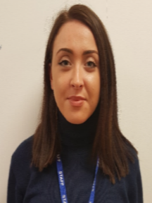 |  | 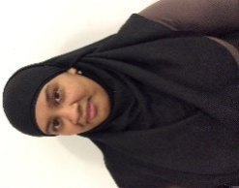 | 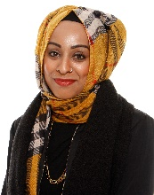
Ms Lola Beckford  Y3 Teaching Assistant | Ms Connie Ioannou  Y1 Teaching Assistant & SEN & Behaviour Specialist | Ms Tracey Peacock  Y2 Teaching Assistant | Ms Sumaiya Mehter  Y3 Teaching Assistant | Ms Tali Khanom  HLTA & Pastoral Care
 |  |  | 1111
Mr Can Ceren  Y1 Teaching Assistant | Katie Hogwood  YR Apprentice Teaching Assistant | Ms Harmesh Kaur  YR Teaching Assistant | Abdou Jeng  Apprentice Sports Coach | Mrs Joanne Kessell  Office Manager
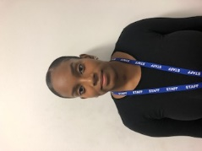 |  | 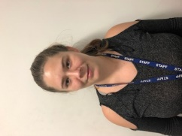 | 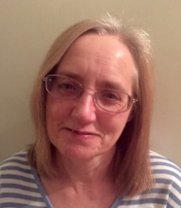
Ms Katanya Findlay  Office Administrator  Lead Midday Supervisor | Ms Natasha Scarborough  Extended Schools Lead | Ms Sasha Haswell  Midday Supervisor | Mrs Margaret Smith  Resources Assistant  Midday Supervisor | Ms Jennifer Conoley  Chef Manager
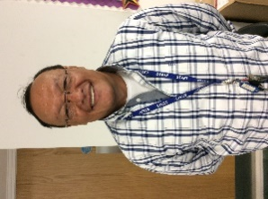
Mr Mauricio Jimenez  Site Manager |  |  |  | Mr Cesar Orellana  Cleaner

